 

CS-114 Fundamentals of Programming (2+1)

DE-41 EE Semester 1

Fall 2019

**LAB REPORT # 04**

|  |  |
| --- | --- |
| **Submitted by** | **Roll No** |
| Ayesha Javaid | 285151 |
| Syndicate A |  |

Instructor In-charge: Dr. Saad Rehman

DEPARTMENT OF COMPUTER & SOFTWARE ENGINEERING

College of Electrical and Mechanical Engineering (CEME)

National University of Sciences and Technology (NUST)

**Lab Number: 1**  
**Lab Title: Nested if else, For Loop , Switch case**  
**Aim:**

**To get the better understanding of Nested if else, For Loop , Switch case**

**Topic(s) covered:**

**Nested if else, For Loop , Switch case**

**(Tasks starting from next page)**

**TASK 1:**

**TASK 1: (NESTED IF/ ELSE)**

Input from user three numbers and display the following on screen:

Largest Number:

Second Largest Number:

Smallest Number:

**Code:**

#include <iostream>

using namespace std;

int main()

{

int a, b, c;

cout << "Enter first number : ";

cin >> a;

cout << "Enter second number : ";

cin >> b;

cout << "Enter third number : ";

cin >> c;

cout << endl;

if (a > b && a > c)

{

cout << "Largest number is: " << a << endl;

if (b > c)

{

cout << "Second largest number is: " << b << endl;

cout << "Smallest number is: " << c << endl;

}

else

{

cout << "Second largest number is: " << c << endl;

cout << "Smallest number is: " << b << endl;

}

}

if (b > a && b > c)

{

cout << "Largest number is: " << b << endl;

if (a > c)

{

cout << "Second largest number is: " << a << endl;

cout << "Smallest number is: " << c << endl;

}

else

{

cout << "Second largest number is: " << c << endl;

cout << "Smallest number is: " << a << endl;

}

}

if (c > b && c > a)

{

cout << "Largest number is: " << c << endl;

if (b > a)

{

cout << "Second largest number is: " << b << endl;

cout << "Smallest number is: " << a << endl;

}

else

{

cout << "Second largest number is: " << a << endl;

cout << "Smallest number is: " << b << endl;

}

}

system("pause");

return 0;

}

**Output:**

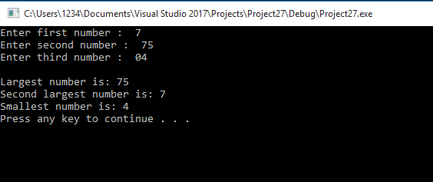

**TASK 2: (SWITCH CASE)**

**Geometry Calculator**

Design a Geometry Calculator.

**Displays the following menu:**

Geometry Calculator

1. Calculate the Area of a Circle

2. Calculate the Area of a Rectangle

3. Calculate the Area of a Triangle

Enter your choice (1-3):

**Code:** #include <iostream>

using namespace std;

int main()

{

int menu;

double area;

double pi = 3.14159, radius;

double length, width;

double base, height;

cout << "Geometry Calculator" << endl;

cout << "1. Calculate the Area of a Circle" << endl;

cout << "2. Calculate the Area of a Rectangle" << endl;

cout << "3. Calculate the Area of a Triangle" << endl;

cout << "Enter your choice(1 - 3): ";

cin >> menu;

cout << endl;

switch (menu)

{

case 1:

cout << "Enter radius of circle: ";

cin >> radius;

while (radius < 0)

{

cout << "Invalid input!" << endl;

cout << "Enter radius of circle again: ";

cin >> radius;

}

area = pi * (radius*radius);

cout << "Area of the circle is: " << area << endl << endl;

break;

case 2:

cout << "Enter length of rectangle: ";

cin >> length;

cout << "Enter width of rectangle: ";

cin >> width;

cout << endl;

while (length < 0 || width < 0)

{

if (length < 0)

{

cout << "Invalid input!" << endl;

cout << "Enter length of rectangle again: ";

cin >> length;

}

if (width < 0)

{

cout << "Invalid input!" << endl;

cout << "Enter width of rectangle again: ";

cin >> width;

}

}

area = length * width;

cout << "Area of the rectangle is: " << area << endl << endl;

break;

case 3:

cout << "Enter base of the triangle: ";

cin >> base;

cout << "Enter height of the triangle: ";

cin >> height;

while (base < 0 || height < 0)

{

if (base < 0)

{

cout << "Invalid input!" << endl;

cout << "Enter base of triangle again: ";

cin >> base;

}

if (height < 0)

{

cout << "Invalid input!" << endl;

cout << "Enter height of triangle again: ";

cin >> height;

}

}

area = base * height * 0.5;

cout << "area of triangle is: " << area << endl;

break;

default:

cout << "Invalid input!" << endl << endl;

break;

}

system("pause");

return 0;

}

**Output:**

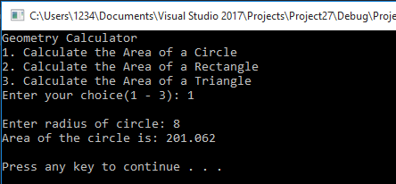

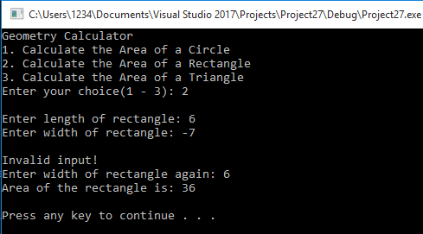

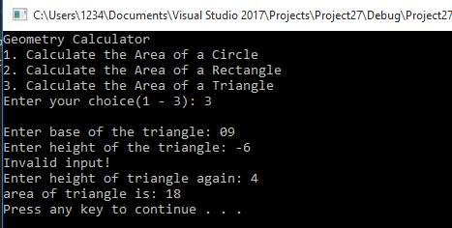

**TASK 3:(FOR LOOP)**

Write a program, which prints the first ‘N’ terms of Fibonacci sequence. Take the value of ‘N’ from user.

Fibonacci Sequence: 0, 1, 1, 2, 3, 5, 8, 13, 21, …

**Code:**

#include <iostream>

using namespace std;

int main()

{

int N, sum, num1, num2;

cout << "Enter the value of N: ";

cin >> N;

cout << "Fibonacci sequence: ";

for (int i = 0; i < N; i++)

{

if (i == 0)

{

num1 = i;

cout << num1 << ", ";

i++;

}

if (i == 1)

{

num2 = i;

cout << num2 << ", ";

i++;

}

sum = num1 + num2;

cout << sum << ", ";

num1 = num2;

num2 = sum;

}

system("pause");

return 0;

}

**Output:**

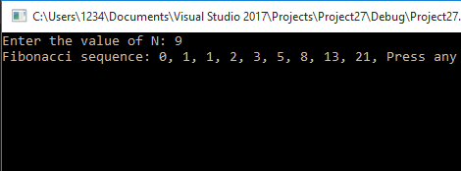

**TASK 4:(FOR LOOP)**

Input 10 numbers and display sum of entered numbers.

**Code:**

#include <iostream>

using namespace std;

int main()

{

int sum = 0;

int a[10];

for (int i = 0; i < 10; i++)

{

cout << "Enter number " << i + 1 << ":";

cin >> a[i];

sum = sum + a[i];

}

cout << "sum is " << sum << endl;

system("pause");

return 0;

}

**Output:**

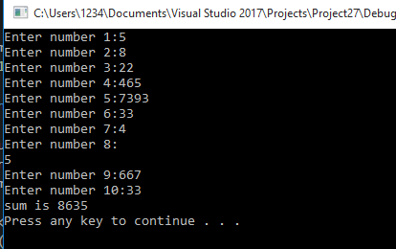

**TASK 5:(FOR LOOP)**

Input ‘N’ numbers from user and sum up only those numbers, which are odd. Also display thecount of odd numbers entered.

**Code:**

#include <iostream>

using namespace std;

int main()

{

int a[10];

int sum = 0;

int count = 0;

for (int i = 0; i < 10; i++)

{

cout << "Enter number " << i + 1 << ": ";

cin >> a[i];

}

for (int i = 0; i < 10; i++)

{

if (a[i] % 2 != 0)

{

sum += a[i];

count++;

}

}

cout << endl;

cout << "Sum of odd numbers is: " << sum << endl;

cout << "Total odd numbers are: " << count << endl;

system("pause");

return 0;

}

**OUTPUT:**

